LINKED LIST LABS

AP Comp Sci

1. TPS: Create your own Linked List

Make a copy of the following files to your student account:

LittleList.java
TestMyList.java

These files are online

The TestMyList file is the driver for the LittleList class

You need to implement the LittleList class so that it works as intended in the Driver program

You need to implement the following behaviors in the LitleList class:

size
addLast
addFirst
remove
removeFirst
removeLast
get
toString

LittleList uses ListNode as a class level attribute

Run the Driver program , TestMyList.java, to test your code

TPS2: Modify the ListNode class

Modify the ListNode class to handle generics. Base and test your modifications against the
Driver program TestListNodeGeneric.java

2. Change LittleList

Implement the Comparable interface to the AirFlight class to compare the flight number

Implement a list of AirFlights using LittleList, but First…

Add the following methods to LittleList:

numLower --- returns count of nodes (flights) lower than given target (flight number)
numHigher --- returns count of nodes (flights) higher than given target (flight number)
numEqual --- returns count of nodes (flights) equal to the given target (flight number)

Use the class in a Driver program to test these methods

3. ListIterator & LinkedList

Write a simple Driver (SPVM) program to illustrate your understanding of the LinkedList class

Use a STANDARD (no generics) LinkedList instance to do the following:

add flights at beginning and the end of the list

traverse the list using the Iterator or ListIterator interface

remove a specific flight (node)

change the flight at a specific node (set)

THEN, Use a Generic LinkedList instance to perform similar functions, IN ADDTITION, make
Sure you utilize the FOR EACH loop in yourTRAVERSAL.

4. JAVA “POE as a Linked List” LAB

Remember the POE project that we developed earlier? Well its back --- in LINKED LIST FORM !!!!

As you hopefully recall, the program processes the text of a book/short story. The text to process is Edgar Allen Poe’s “The Cask of Amontillado”. You can find this text on my website.

Process the text to obtain the following information:

- The total number of words
- The number of unique words
- The most freequent word and how many times it is used
- List all the other unique words and how many times they are used

In order to accurately determine word counts, you need to eliminate the differences between case sensitivity. For example, the following are all considered the same word:
The
the
THE

In addition, make sure you eliminate and punctuation from a word. Otherwise, you may inadvertently include it as part of a word.

Once this is completed, add functionality for a user to enter a word. The program must search a listing of unique words and return the number of times that word occurs, IF FOUND, otherwise return a “WORD NOT IN BOOK” message.

THE DIFFERENCE HERE, however, is that you MUST implement your data structure as a Linked List. You must use the ListNode and NOT the LinkedList class !!!

In the first version, we implemented the data structure that held the unique words as an array. When a unique word was identified we simply added it to a new element on the array. At the end of the story, we sorted and then searched the array for the required information.

Now, you will store the unique words and their counts in a linked list. Depending on how you organize your linked list, you can have a very inefficient program that takes a great deal of time, 20-30 minutes, to execute.

One suggestion is that you combine an array (or arraylist) with a linked list so that you can break your stored information into 26 separate lists (get the hint !!!). Also, unlike the previous assignment where you may have sorted the array at the end, you may want to avoid such a travesty here by “sorting” as you go (get this hint !!!).

Finally, a BONUS of 20, then 15 then 10 points will be given to the 3 students whose program execute the fastest.

Also, display the time when you first start the search. Then display the time when the search is completed. You must get the current time, in seconds, when you first enter main and then get the end time just before you return from main. Post the elapsed time as the last line displayed.

The output Should Resemble the following:

The total number of Words in poe.txt is :2324
The number of Unique words is : 809
the is the most frequent word and it occurs 168 times
start time is 996962718 end time is 996962718
elapsed time is 0.6599999666213989

Enter a Word to Search➔ the
The WORD FOUND and occurred 809 times

- GridWorld Case Study Lab

The GridWorld Case Study is detailed in the PDF file:

Grid World Narrative.pdf , which can be found on the AP page in the “Grid World Case Study” link.

READ the following sections of the NARRATIVE :

PART 3 page 15 --- Grid World Classes and Interfaces

This deals with the interactions and class relationships between the
Location class, Actor Class (bugs) and the Grid (bounded, unbounded
Environment)

Make sure you UNDERSTAND the relationships between the parts of
The GridWorld (Actor and children, Grid Interface and its users, Location)

- DO THE GROUP ACTIVITY on page 24 (Jumper)

PART 5 page 35 --- Grid Data Structures **** SEE IMPLEMENTATION NOTE THAT
AT END OF THIS DOCUMENT

This deals with Grid, AbstractedGrid, Bounded and UnBounded Grids.

Again, Make sure you UNDERSTAND these relationships and the role
Of the “World” class.

- DO EXERCISES 1 and 3 on pages 38 – 40

Exercise 1 requires you to a new grid called SparseBounded Grid.

Exercise 3 requires you to implement and then detail the efficiency of an UnBounded Grid that stores elements using an array.

*** IMPLEMENTATION NOTE FOR EXERCISE 1:

All of the grid, location, actor, world and environment classes for this case study are compiled and packaged in the gridworld.jar file which you already added in your libraries when you completed the summer assignment.

You can view the SOURCE code for these classes in the following directory:

GW Code\GridWorldCode\framework\info\gridworld
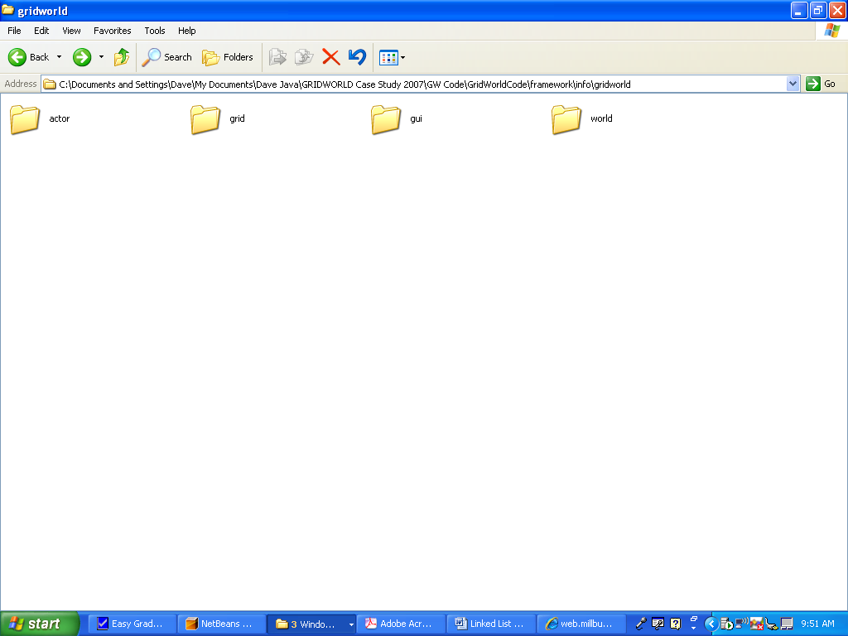

TO view specific class code, go into the appropriate folder:

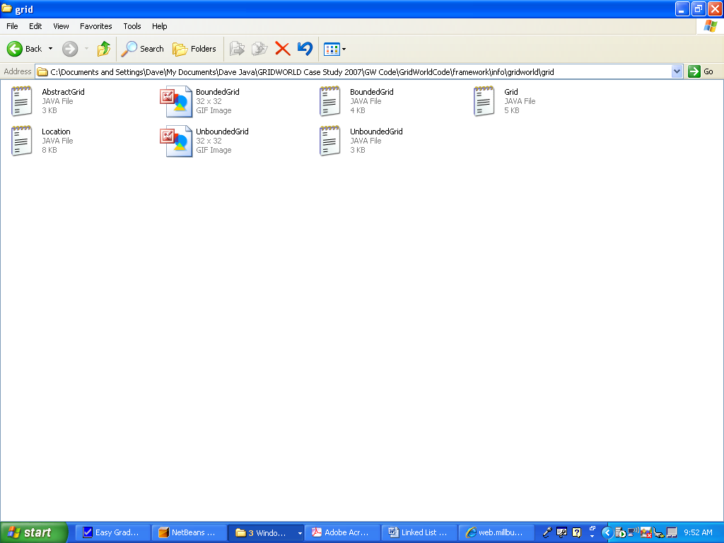

You can then “copy” an existing grid environment (bounded or unbounded) , rename the class and copy it into your existing GW project. Then modify it to execute as a sparse matrix utilizing Linked Lists.

You will have to adjust the imports and comment out the package as this class was originally looking into the jar files for supporting classes:

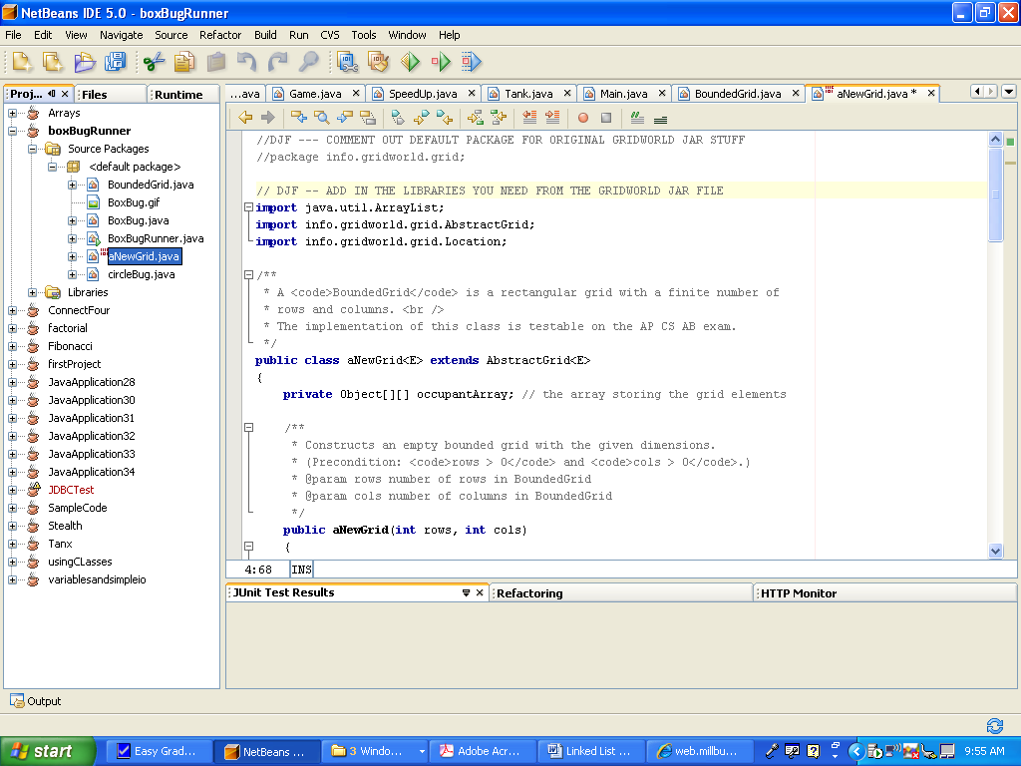

Finally, add the environment to the world by adding the class in your driver:

